

UNDER EMBARGO UNTIL 00:01, TUESDAY 11th JUNE 2024
Introducing SilentPower – Bringing Innovative Power Solutions to All

Southport, UK: iFi audio, a trailblazer in high-fidelity audio components, proudly announces the launch of its new sister-brand: SilentPower. This new venture brings innovative and affordable power and signal solutions to the masses, born from iFi audio’s relentless pursuit of silence in audio systems.
In 2015, iFi scoured the market to find the quietest power supplies possible but found that current offerings either fell short of their rigorous standards or were prohibitively expensive. Recognising their technical expertise, iFi audio embarked on a mission to design power solutions that not only met but exceeded their high standards, with the goal of unlocking the last 10-30% of performance in Hi-Fi systems.
SilentPower products are organised into four categories: Power Supplies, Cables, Conditioners and Accessories. Each category features proprietary technologies designed to eliminate EMI, RFI, jitter, ground loops, and hum, ensuring every connection in your Hi-Fi system delivers clean, clear sound.
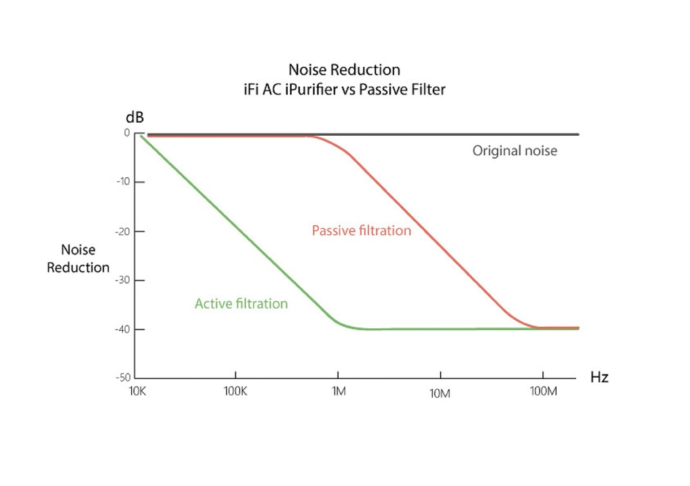

SilentPower Technologies

Active Filtering for Pure Signal Transmission
SilentPower employs advanced active filtration technology, specifically Active Noise Cancellation II, across all product categories. Inspired by military radar cancellation techniques, this technology duplicates incoming noise and inverts its polarity, effectively cancelling out electromagnetic and radio interference. This approach is especially effective for low and mid-frequency noise, while passive insulating filters tackle higher frequency interference. The result is a noise floor more than 10 times quieter than typical audiophile solutions.
Optical Isolation
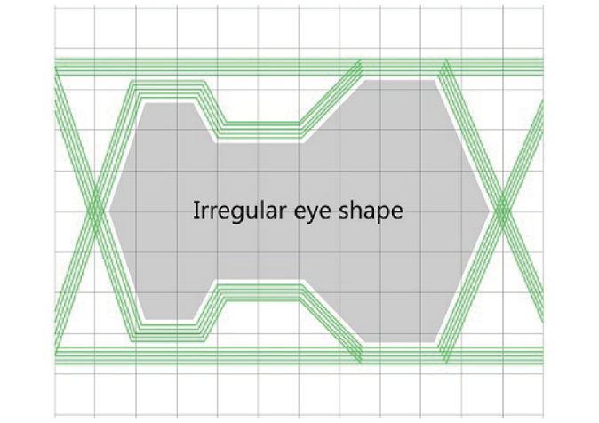

USB interfaces, while capable of passing high-resolution audio data, can introduce noise that degrades sound quality. SilentPower’s USB conditioners feature galvanic isolation, which separates electrical circuits to eliminate stray currents – such as differences in ground potential or currents induced by AC power or RF noise.
Optical galvanic isolation, which converts signals to light and back - removes noise across the entire frequency spectrum, as typical galvanic isolation alone may not be able to effectively suppress HF noise leakage caused by parasitic capacitance.
These features are highly desirable for CAS audiophiles and those streaming content, as they significantly reduce jitter, enhance timing and improve musicality during digital-to-analogue conversion.

Ground Zero Technology
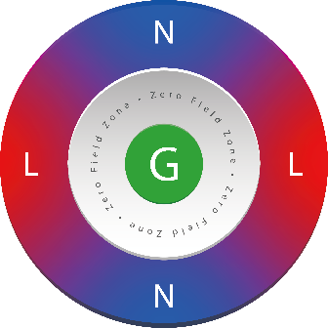

SilentPower’s Ground Zero technology is a unique feature in their power cables. Here, the ground wire is surround by live and neutral wires in a geometrically balanced pair. The shotgun configuration of the ground conductor prevents the ground wire from being affected by magnetic fields, and the balanced design maintains constant impedance regardless of whether the cable is angled or bent – ensuring pure mains electricity feeds into your audio or AV system.

Excess Earth and DC Blocking Solutions
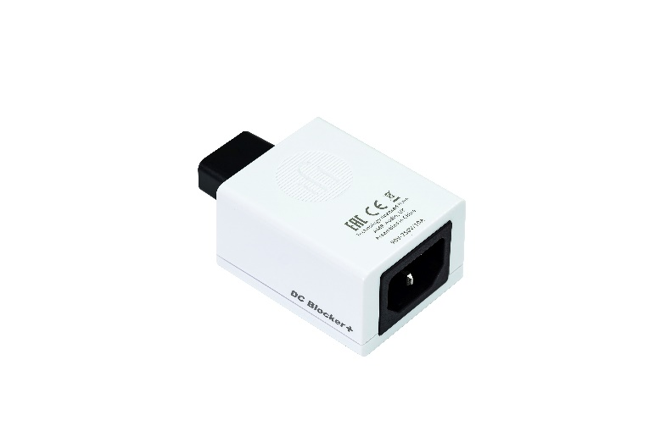
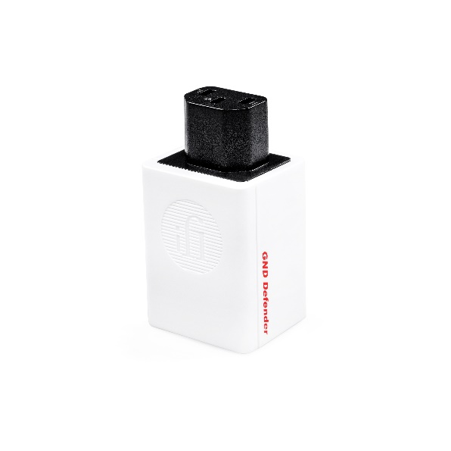

Buzz and hum are common issues caused by excess earth connections or DC on the mains, and are audible through speaker and headphone setups. SilentPower addresses these problems with products like the GND Defender (and iDefender+ USB variant) or the DC Blocker.
The GND Defender and iDefender+ intelligently removes the excess earth connection to eliminate ground hum while retaining equipment safety and EMI shielding. These devices automatically reinstate a ground connection if a fault is detected, ensuring protection for both equipment and users. For further protection, units come with built-in surge protection boasting an overload rating of 220A.
The DC blocker tackles the issue of DC offset, which can cause persistent humming in transformers, most often experienced with amplifiers. By blocking over 1,000mV DC, the DC Blocker eliminates hum without compromising EMI shielding or safety.
SilentPower’s stackable design allows users to combine these solutions for maximum effectiveness.

Enter the Realm of Silence: Unveiling the LAN iPurifier Pro
SilentPower is proud to introduce the LAN iPurifier Pro, an advanced ethernet noise filter designed to enhance the quality of music and video streaming. Leveraging state-of-the-art optical galvanic isolation and jitter elimination technology, the LAN iPurifier Pro offers a plug-and-play solution that eliminates noise interference, delivering a superior streaming experience.
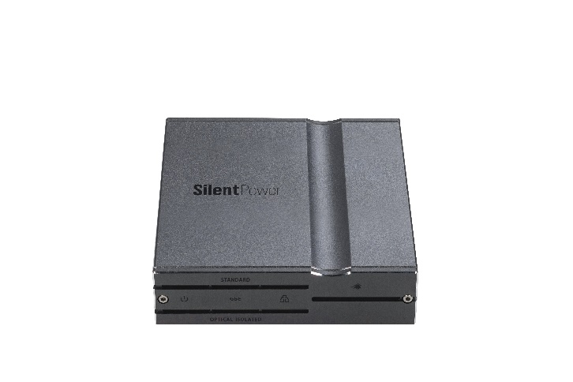
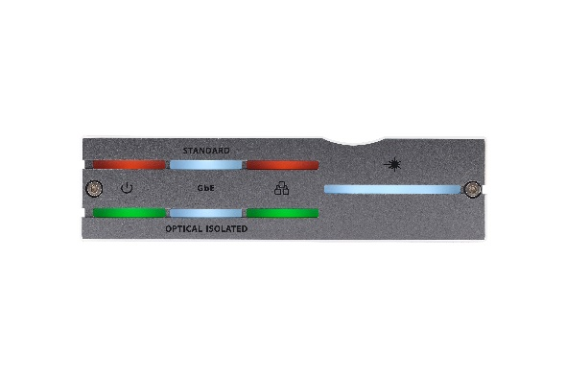

Revolutionary Design for Seamless Integration
Traditionally, achieving optical galvanic isolation required a complex setup involving multiple media converters, power supplies, and extensive cabling. The LAN iPurifier Pro revolutionises this process by providing a compact, elegant solution that easily fits between your router and streamer.
Its design ensures complete isolation of input from output, effectively eliminating electrical noise, interference, and stray currents from the router or switch. This significantly reduces system noise, errors, and jitter – thereby improving timing at the digital-to-analogue conversion stage.
As transformer isolation leaks through HF noise, caused by parasitic capacitance and inductance from the common-mode coupling channel between the primary and secondary sides of the transformer. Optical isolation is superior at reducing noise across the whole frequency spectrum, as light is immune to leakage from capacitance.

Superior Performance with Advanced Features
The LAN iPurifier Pro employs multiple strategies to ensure a jitter and noise-free experience. After isolating the signal, it regenerates the signal using active circuitry to reconstruct the binary data stream, further reducing overall jitter and improving system timing.
As this is an active device, the LAN iPurifier Pro features USB-C 5V DC input port that can be powered by the included adapter or from a PC USB port. Inside, an ultra-low noise DC-DC power supply ensures clean power delivery. For those seeking even higher performance. The power supply can be upgraded with a 5V SilentPower iPower series power supply, featuring proprietary active filtration.

Unmatched Speed and Compatibility
Designed for transparent data transmission, the LAN iPurifier Pro meets 1000BASE-T and IEEE 802.3x standards, ensuring speed without compromise. Due to Gigabit Ethernet support, it is suitable for both home and office use and is compatible with a wide range of network devices, including 4K media boxes and media streaming PCs.

User-Friendly Features
The front panel of the LAN iPurifier Pro is equipped with diagnostic LEDs that provide real-time status updates on power, connection and data speeds for both input and output. The brightness of these LEDs can be adjusted using a button located on the rear of the unit, offering users complete control over their setup.

Experience the Future of Streaming
SilentPower’s LAN iPurifier Pro represents a significant advancement in network noise filtration, promising a more immersive streaming experience. Whether for home or professional use, it is the ultimate solution for those seeking the highest quality in digital media streaming.

